Assignment 8

Minesweeper – Part 3 of 3

This the third part of this three week assignment, the main goal of the first week was to have your GUI setup, and the main goal of the second week was to make the game play working. Now in week 3, we are giving the game some polish with some extra features.

You will need to implement:

* A left click on an uncovered number tile that already has the correct number of flags around it will uncover all the remaining covered tiles in it’s group of 8.
* The first click of every game is always on a spot with 0 mines around it. The surrounding spots with no mines around are also opened automatically. This is usually done using recursion.
* When the game is over, after a win or loss, the only clickable button is the face button.

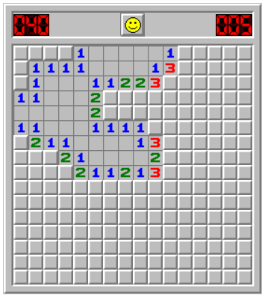

The image above has all these tiles uncovered after one click. The first click of a game is always on a zero (blank) tile. The recursively clears the 8 spots surrounding blank tiles.

When you are done part 2, submit the java files, and:

# **You must also show me in person in lab!**

**You can implement for bonus marks:**

* Create a difficulty menu, which has the 3 different difficulty levels.
* The time elapsed
* Keep track of high scores, and add them to the menu. High scores are based on least amount of time elapsed it took to beat a particular difficulty level. Keep the fastest time per difficulty level.
* Show the elapsed time and mines left in the original red digit style (ask Ken for images).
* Make a nice border around the mines, so it looks like the screen shot above.
* Use the Face-O graphic while the mouse is pressed, but not yet realeased.
* Use the misflagged graphic in the event the user clicks on a mine, and there was a flag on a tile that wasn’t actually a mine.

For the highscores, you will need to ask for a name

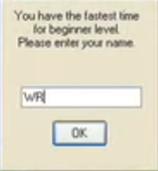

Then display them as you wish, here is just one example.

